Sustainability in Agriculture: 9-12
No. of students/teachers: No. of staff:
Lesson Overview: As community members of a local and global ecosystem, we have a responsibility to practice sustainable stewardship of the earth. Students learn about the sustainable, organic practices on our working production farm, and engage in deeper conversation about environmental responsibility, local food systems, and climate action.

Outcomes: The farm as a context for introducing sustainability principles and to foster a conservation ethic.
Sustainability becomes the lens to explain the connection between the environmental, social and economic aspects of a working farm.
Evidence of Learning:
Learning Standards:
NGSS:

HS-LS2-7 Design, evaluate, and refine a solution for reducing the impacts of human activities on the environment and biodiversity.

HS-ESS2-4 Use a model to describe how variations in the flow of energy into and out of Earth’s systems result in changes in climate.

HS-ESS3-3 Create a computation simulation to illustrate the relationships among the management of natural resources, the sustainability of human populations and biodiversity.

USPESD Standards
Environmental Stewardship - Students design a restoration plan for a local environment that describes the natural resources, through field-based data collection, and includes the social, economic, and political mechanisms to
preserve and enhance the described environment.

Food Systems - Students analyze local, national and global food systems, demonstrating an understanding of the differences between industrial farming, factory farming, family farming, organic, and non-organic farming.

Big Ideas of Sustainability
Systems
Long Term Effects
Change over time

Social Studies Standards
Recognize dynamics of historical continuity and change over periods of time.

Identify how environments affect human activities and how human activities affect
physical environments.

Places of Engagement used to enhance the relevance of the experience:
Hilltop Hanover decides where to conduct the inquiry

Timing | Plan | Notes & who
15 min | Welcome: guidelines for program  Energy Ball activity | -energy balls
Engage:  30 min | Where Does Your Food Come From?  - Ask students where they typically get their food from. Discuss. Answers will vary, but most are grocery store  - Where does the grocery store get its food from? Discuss.  - Distribute pictures to different students to put on the world map  - Bananas - mostly imported from any hot, tropical ecosystems like Costa Rica, Ecuador, Columbia, and Peru  - Oranges - mostly domestic from California, Florida, Texas, and Arizona  - Potatoes - Domestic, can be grown in nearly every state but most come from Idaho, Washington, Wisconsin  - Apples - Domestic, 32 states grow apples, largest producing state is Washington (65% of total)  - Coffee Beans - Mostly Imported, Columbia and Brazil  - Beef - 80% domestic and 20% imports; Texas and Oklahoma raise the most; most imports come from Canada  - Chicken - Domestic, Iowa, Indiana, Illinois are the top states raising chickens  - Fish - Mostly imported; China, Thailand, and Canada are the top three  Discuss what all needs to go into getting the food to the consumer after it is grown.  Calculation for transportation* | Materials: World Map and pictures of typical food items and where they’re grown  *may want to add a fun fact/etc on the back of each picture about the food
Inform:  60 min  (20 min demo, 40 min tour) | Crop Cover and Runoff Demo:  Build two demonstrations one with just bare soil and one with some sort of cover crop (grass)  - Start by briefly talking about the process of harvesting crops and what might happen after a crop is harvested  - Compare the two plots initially before a rain event - discuss  - Complete a rain even - discuss which plot has more runoff and what might be in that runoff  Tour the farm  Items to talk about during the tour:  - how the crops are grown  - pesticides/herbicides/fertilizer  - irrigation/watering  - how crops are harvested (machinery/tools used)  - What happens after harvesting when the field is fallow?  - How Hilltop farms compared to industrial farming practices  - Organic vs. inorganic farming  - seeds: GMO/ancient grains/etc  - animal welfare (CAFOs vs. free range)  - food packaging | 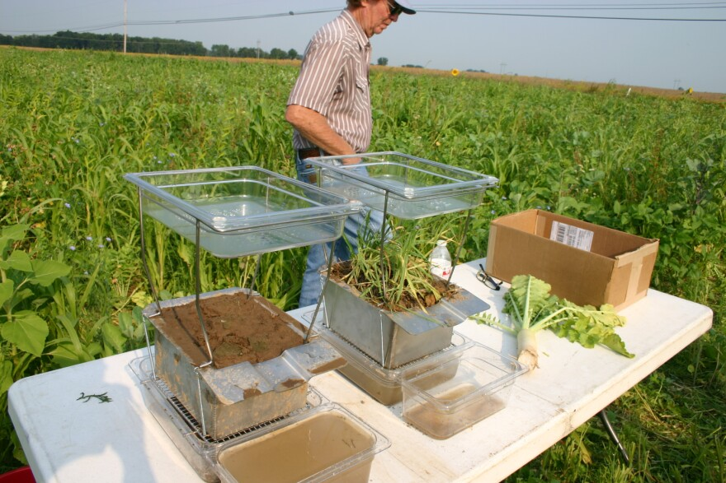
Apply:  65 min (50 min field work, 15 min calculation) | Field work and activities  - Seasonally-appropriate (plant, cultivate, harvest, prepare for winter)  - How are Hilltop’s practices compared to industrial farming practices?  - Discuss: 1 large group of students, arrived by bus, making impact in field vs. field crew in own cars vs. tractor vs. plastic vs. landscape fabric vs. straw/hay  Do a calculation in the field.  Calculation #1:  Carbon footprint of food transportation.  Calculate the amount of greenhouse gasses emitted while transporting the foods discussed in the Engage sections.  Assume these baseline emission numbers for the three main modes of cargo transportation to help calculate the carbon footprint for each food item.  - Heavy Duty Diesel Trucks emits 80 grams of CO₂ per tonne of cargo per kilometer driven  - Bulk shipping carrier emits 7.9 grams of CO₂ per tonne of cargo per kilometer traveled  - Cargo plane emits 435 grams of CO₂ per tonne of cargo per kilometer flown  Find out/display the kilometers traveled for each food item.  Have students calculate the total amount of CO₂ released by transporting the food item to their grocery store/house.  For added calculations, have students convert kilometers to miles and grams to pounds.  Discuss. | *emission rate data came from the International Chamber of Shipping website  -note the concept of LCA for non-food items
Wrap Up:  10 min | Discuss simple, direct ways students can eat more sustainably in their own home. Take home materials: recipes, worksheets etc
Departure:

