Hilltop Hanover Farm Visit Curriculum: Senses of the Farm
Age groups: Pre-k through 6th suggested; can be scaled accordingly

Overview: Younger children delight in this multi-sensory introduction to the world around them through a deep exploration of each of their five senses in this eye-, ear-, fingertip-, nose-, and mouth-opening experience. The vivid purple of an eggplant flower, lavender’s waft of calm, and the bright taste of a cherry tomato are all tools that guide students into curiosity and connection, while allowing educators to engage topics of community, (bio)diversity, food sources, and earth and life cycles.

Outcomes:
Younger students
- recognize and describe colors, scents, textures, tastes and sounds;
- learn fundamental concepts of life cycles (seed, sprout, flower, fruit) and earth cycles (sun, soil, water, decomposition);
- learn the basic concepts of ecosystem biodiversity
Older students will, in addition:
- demonstrate ability to conduct objective observations, use accurate & descriptive language, and independently identify biological characteristics
- learn to connect the concepts of farms, food, and community to biodiversity and the health of human and environmental systems

Big Ideas & Standards: Life cycles, Community/Place, Relationships—processes—interdependence, Diversity, Limits
Sustainability 3.9d, The Living World 7.13a,b,c,d,

Materials: paper, drawing & writing utensils, hardboards (if working outdoors), hand lenses (optional)

Methods:
1. Begin with a tone-setting activity to introduce students to their observational capabilities.
- Look Closely (younger): gather around an object/flower/plant/leaf/fruit/vegetable of choice. In silence, students observe for 30 seconds. In a circle, each student states one observation. No repeating. Nothing is too simple or basic! Try to cover every possible angle, method of sensing, and quality. Best in smaller groups of 7-10, so multiple groups/educators suggested.
- No-Eyes Detectives (older): group students in pairs or threes, and have them take turns closing their eyes as their peer(s) lead them to a special spot (can be a plant, a tree, a patch of lawn, a vegetable, etc). Using smell, touch, and sound, let them try to guess what they are experiencing and list 3 descriptors (i.e. feels spiky, sounds smooth, smells green) before opening their eyes.

2. Introduce students to the farm with a visit to the growing spaces in the Children’s Garden, Greenhouse/High Tunnel, and Fields. Seasonally-available produce will direct the specifics, but follow this flow:
- Engage (ask) students in a conversation about farming: what do farms do? Grow food. Where does growing happen? Follow students’ suggestions: if they point out the fields, go there first. Direct them with suggestions if necessary.
- Guide students through macro- to micro-observation of several different crop species as you move through the fields. Begin with observation of color schemes, any smells, and sounds, before moving closer. As you zoom in, ask them to discover something surprising about this species: e.g., “this pepper feels much softer than I thought”, “this turnip is barely in the earth”, or “I can smell the radish without even eating it”. With each species, notice with as many senses as possible, tasting where appropriate. Advise them to remember as much as they can.
- Choose one crop to focus on, e.g., cherry tomato. Process the life cycle of the crop / cherry tomatoes through close observation of each characteristic. Make sure to guide them with organic practices.

“Does it have seeds? Where are they?” (small, yellow, in fruit) …
“What happens when the seed is planted? What kind of plant grows from this seed?” (hairy vines, bendy and strong, green, tall, smaller leaves) …
“Do we eat the plant or its fruit? How does it fruit? What is fruit?” (fruit, via yellow small flowers, the seed-bearing organ, it tastes delicious so that creatures eat it) …
“Are there other kinds of tomatoes? Why?” (thousands, human preference, biodiversity, genetic diversity, heirloom varieties) …
“What happens when the tomato has gotten ripe? How does it create more tomatoes?” (Falls on the ground, rots, smelly)…
“Are there any imperfections, bugs, pests, funny looking shapes? Why?” (Tomato hornworms, no pesticides because parasitic wasps help, organic practices mean fruit can look different from in a grocery store)

3. Visit the goats and cows. Make observations about smells, colors, sounds, and different body morphologies of the breeds together. These animals are excellent tools for talking about closed-loop sustainable agriculture (using their poop in our compost and fields), pasture health (rotational grazing), community (visitors love the farm, the cows are a family, the goats are social), biodiversity (meat vs dairy goats, rare cattle breed), and the green roof on the goat shed.

3. Solidify students’ understanding of earth and plant cycles and sustainable agriculture with a visit to the compost. Follow the same flow as above. E.g.:
- Bay 1 is fresh and smelly, with visibly distinct vegetables, organic matter, and manure, while Bay 4 is old, cold, and dry.
- Have students run around for 15 seconds. Are they warmer? Explain microbial decomposition and have them guess the temperature of each pile. Check the thermometers to see if they’re right.
- What ingredients make compost, and where do they come from? Where is compost used?

4. In closure, provide a handout guiding students to create an observational web about one organism they experienced during their visit. At the center, a visual representation of this organism (remember, the focus is on accurately representing what they notice, not creating a to-scale drawing); expanding webs of detailed notes using information gathered from each sense; for older students, connect to a tertiary web of other organisms on the farm, humans, the local environment, and beyond. Example below.

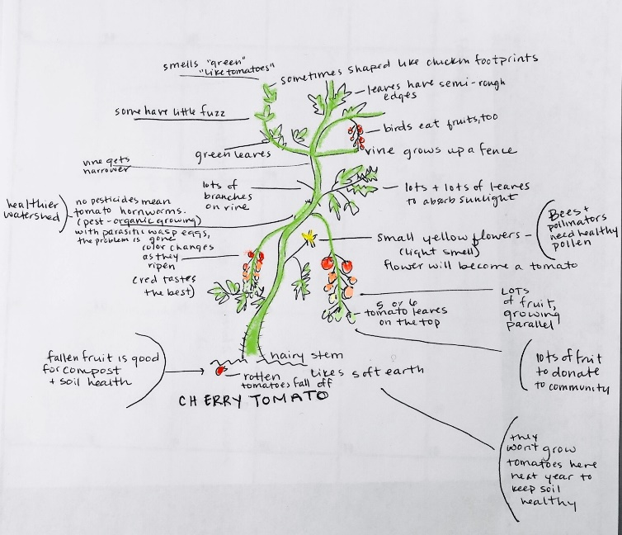
Hilltop Hanover Farm & Environmental Center Name:
Senses of the Farm

1. You’ve just examined many different plants and animals with all your senses! Now, it’s time to record your observations. Pick one organism you remember from your visit.

2. Draw your organism below. Using your memory of what you saw, smelled, tasted, heard, and felt, make sure to include all the information you gathered. You may use words for smells, tastes, and sounds.

3. Label the parts of your drawing, so that your observations are useful for anyone who sees it. How do your observations connect to what you have learned about healthy people, ecosystems, & environments?
Connect these key words with parts of your drawing:
COMPOST ORGANIC PESTICIDES BIODIVERSITY COMMUNITY FOOD

